SESSION 13
t-tests (One-sample & Two-sample)
Assignment Notes with Worked Demo
Topics covered: When to Use a t-test | One-sample t-test | Independent t-test | Paired t-test | Demo (Python): Average Revenue Before vs After a Marketing Campaign

1. When to Use a t-test
A t-test checks whether a difference between means is larger than what we would expect from random sampling variation. It is used instead of the z-test when the population standard deviation σ is unknown and has to be estimated from the sample standard deviation s. This is the usual situation in practice, especially with small samples.

1.1 Conditions
- The data are numerical (interval or ratio scale), such as revenue, order value or time.
- The sample is random and the observations are independent (apart from the deliberate pairing in a paired test).
- The data are approximately normal, or the sample is reasonably large (the CLT helps when n is about 30 or more). With small samples, check for strong skew or outliers.
- For the independent test, the two groups are separate; for the paired test, the two measurements come from the same units.

1.2 The t-distribution
The t-distribution is bell-shaped and centred at zero like the normal distribution, but has heavier tails, which allows for the extra uncertainty from estimating σ. Its shape depends on the degrees of freedom (df); as df grows, it approaches the standard normal distribution.

1.3 Which t-test?
Test | Question answered | Data layout
One-sample | Is the mean of one group equal to a known or claimed value? | One sample, one benchmark value
Independent (two-sample) | Do two separate groups have different means? | Two unrelated samples
Paired | Did the mean change for the same units, e.g. before vs after? | Two measurements on each unit

2. One-sample t-test
Tests whether the mean of a population differs from a specified value μ₀.
t = (X̅ − μ₀) / (s / √n), df = n − 1
Hypotheses: H₀: μ = μ₀ versus H₁: μ ≠ μ₀ (or > / < for one-tailed tests).

Example
Problem: A store claims its average order value is Rs. 500. A random sample of 12 orders (in Rs.) is: 520, 480, 555, 510, 495, 540, 565, 500, 530, 515, 545, 525. Test the claim at α = 0.05.
Sample results: n = 12, X̅ = 523.33, s = 25.26.
SE = 25.26 / √12 = 7.29
t = (523.33 − 500) / 7.29 = 3.20, df = 11
Decision: The critical value is ±2.201 and the two-tailed p-value is 0.0084. Since |t| = 3.20 > 2.201 (and p < 0.05), reject H₀. There is evidence that the true average order value differs from Rs. 500; the sample suggests it is higher.

3. Independent (Two-sample) t-test
Compares the means of two separate, unrelated groups. H₀: μ₁ = μ₂ versus H₁: μ₁ ≠ μ₂.

3.1 Pooled version (equal variances)
t = (X̅₁ − X̅₂) / ( sₚ × √(1/n₁ + 1/n₂) ), df = n₁ + n₂ − 2
sₚ² = [ (n₁ − 1)s₁² + (n₂ − 1)s₂² ] / (n₁ + n₂ − 2)

3.2 Welch’s version (unequal variances)
t = (X̅₁ − X̅₂) / √( s₁²/n₁ + s₂²/n₂ )
Welch’s test adjusts the degrees of freedom and does not assume equal variances. It is the safer default, and it gives almost the same answer as the pooled test when the variances are similar.

Example
Problem: Compare average daily sales (Rs. thousand) of City stores and Town stores.
Group | n | Mean | Std. deviation
City stores | 12 | 130.50 | 7.91
Town stores | 11 | 110.91 | 8.09

Test of equal variances (Levene): p = 0.92, so equal variances are reasonable. Pooled test: t = 5.87 with df = 21, p ≈ 0.000008. Welch: t = 5.86, p ≈ 0.000009.
Decision: p is far below 0.05, so reject H₀. City stores have a significantly higher average daily sales than Town stores, by about Rs. 19.6 thousand.

4. Paired t-test
Used when the same units are measured twice (before and after), or when observations are naturally matched. The test works on the differences d = after − before, so it becomes a one-sample t-test on the differences with a hypothesised mean of zero.
t = d̅ / (s_d / √n), df = n − 1
Here d̅ is the mean of the differences, s_d is their standard deviation and n is the number of pairs.
Why pair? Pairing removes the variation between units (for example, big stores and small stores), so the test focuses on the change within each unit. It is usually much more powerful than an independent test on the same data, as the demo below shows.
Hypotheses: H₀: μ_d = 0 (no change) versus H₁: μ_d ≠ 0, or μ_d > 0 if we only test for an increase.

5. Demo (Python): Average Revenue Before vs After a Marketing Campaign

5.1 Problem statement
A retailer ran a marketing campaign. Monthly revenue (Rs. thousand) was recorded for the same 12 stores in the month before and the month after the campaign. Did the campaign increase average revenue? The data are illustrative for this demo.

5.2 Choosing the test
The same 12 stores are measured twice, so the data are paired. A paired t-test is the correct choice.

5.3 Hypotheses
Hypothesis | Statement | In words
H₀ | μ_d ≤ 0 | The campaign did not increase average revenue
H₁ | μ_d > 0 | The campaign increased average revenue

Significance level α = 0.05 (right-tailed test), where d = After − Before.

5.4 Data
Store | 1 | 2 | 3 | 4 | 5 | 6 | 7 | 8
Before | 120 | 135 | 98 | 150 | 110 | 142 | 125 | 105
After | 128 | 141 | 105 | 158 | 112 | 155 | 130 | 113
Difference | 8 | 6 | 7 | 8 | 2 | 13 | 5 | 8

Store | 9 | 10 | 11 | 12 | Mean
Before | 160 | 130 | 115 | 138 | 127.33
After | 172 | 134 | 126 | 147 | 135.08
Difference | 12 | 4 | 11 | 9 | 7.75

5.5 Python code
import numpy as np
from scipy import stats

before = [120,135,98,150,110,142,125,105,160,130,115,138]
after = [128,141,105,158,112,155,130,113,172,134,126,147]

# Paired t-test (one-tailed: after > before)
t, p = stats.ttest_rel(after, before, alternative='greater')
print('t =', t, ' p =', p)

# Mean difference and 95% confidence interval
d = np.array(after) - np.array(before)
se = d.std(ddof=1) / np.sqrt(len(d))
tc = stats.t.ppf(0.975, len(d) - 1)
print(d.mean(), d.mean() - tc*se, d.mean() + tc*se)

# For comparison: wrong test (independent)
print(stats.ttest_ind(after, before, equal_var=False))

5.6 Results
Quantity | Value
Mean revenue before | Rs. 127.33 thousand
Mean revenue after | Rs. 135.08 thousand
Mean difference d̅ | 7.75
Std. deviation of differences s_d | 3.25
Standard error s_d / √12 | 0.938
t statistic (df = 11) | 8.26
p-value (one-tailed) | ≈ 0.0000024
Critical value (α = 0.05, one-tailed) | 1.796
95% CI for mean difference (two-sided) | (5.68, 9.82)

t = 7.75 / (3.25 / √12) = 7.75 / 0.938 = 8.26
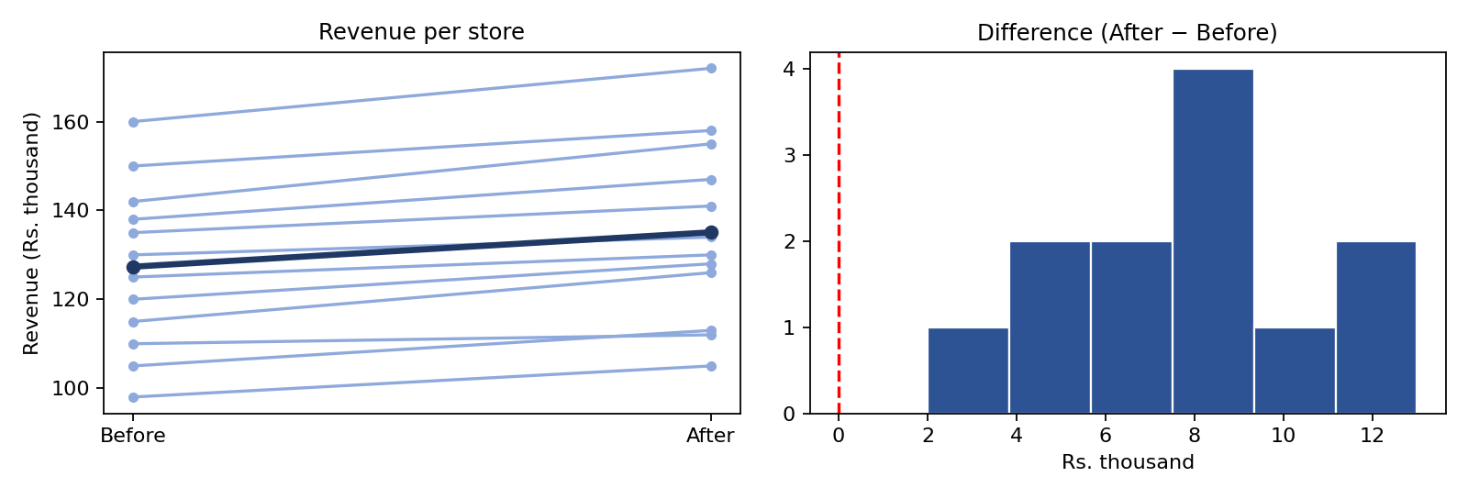
Figure 1: Revenue before vs after the campaign (left) and the distribution of differences (right)

5.7 Decision and conclusion
Since t = 8.26 is greater than the critical value 1.796 (and p ≈ 0.0000024 is less than 0.05), we reject H₀. There is strong evidence that the marketing campaign increased average store revenue. Average revenue rose by about Rs. 7.75 thousand per store (roughly 6%), and the 95% confidence interval for the increase is Rs. 5.68 to Rs. 9.82 thousand, which does not include zero.
Assumption check: All 12 stores improved, and the Shapiro–Wilk test on the differences gives p = 0.97, so there is no sign of non-normality.
Why the paired test matters: If we wrongly treated the before and after figures as two independent groups, we would get t = 0.97 and p = 0.34, and wrongly conclude that there is no effect. The stores differ greatly in size (revenue from 98 to 160), which hides the consistent improvement. Pairing removes that store-to-store variation.
Caution: A before-and-after comparison cannot by itself prove the campaign caused the rise, because season, festivals or other changes may also matter. A comparison group of stores without the campaign would make the conclusion stronger.

6. Formula Cheat Sheet
Test | Formula
One-sample t | t = (X̅ − μ₀) / (s / √n), df = n − 1
Independent t (pooled) | t = (X̅₁ − X̅₂) / (sₚ √(1/n₁ + 1/n₂)), df = n₁ + n₂ − 2
Independent t (Welch) | t = (X̅₁ − X̅₂) / √(s₁²/n₁ + s₂²/n₂)
Paired t | t = d̅ / (s_d / √n), df = n − 1
Confidence interval (mean) | X̅ ± t* × s / √n
Decision rule | Reject H₀ if p ≤ α (or |t| > critical value)

